**Overall Base Errors (Across one-step, short-term and full horizons)**

** While the base errors reduce as the number of forecast steps are reduced for all datasets, for tourism this is the opposite

**Prison**

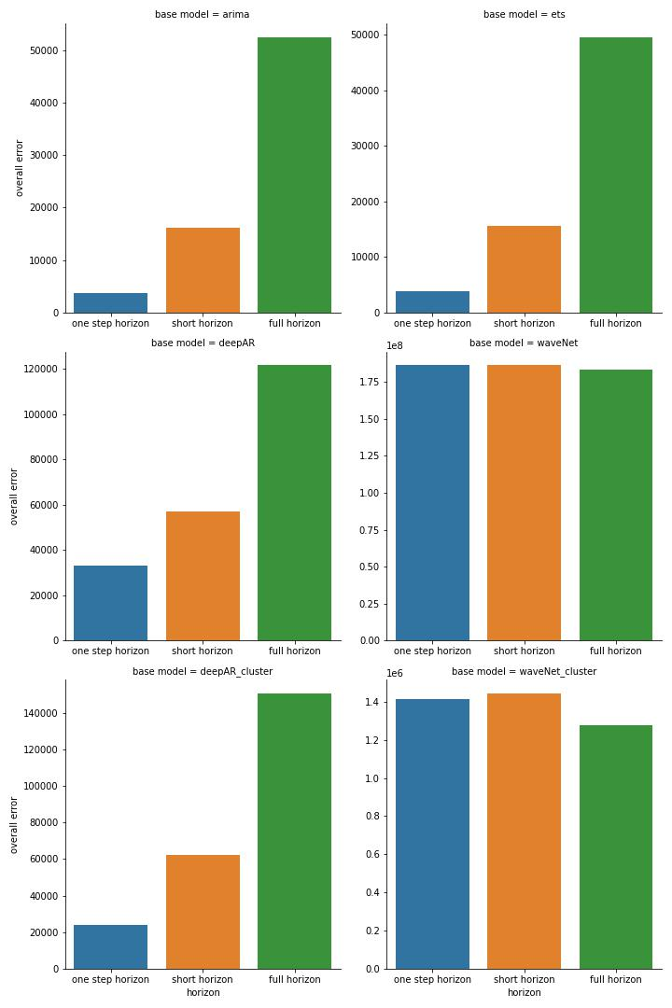

**Tourism**

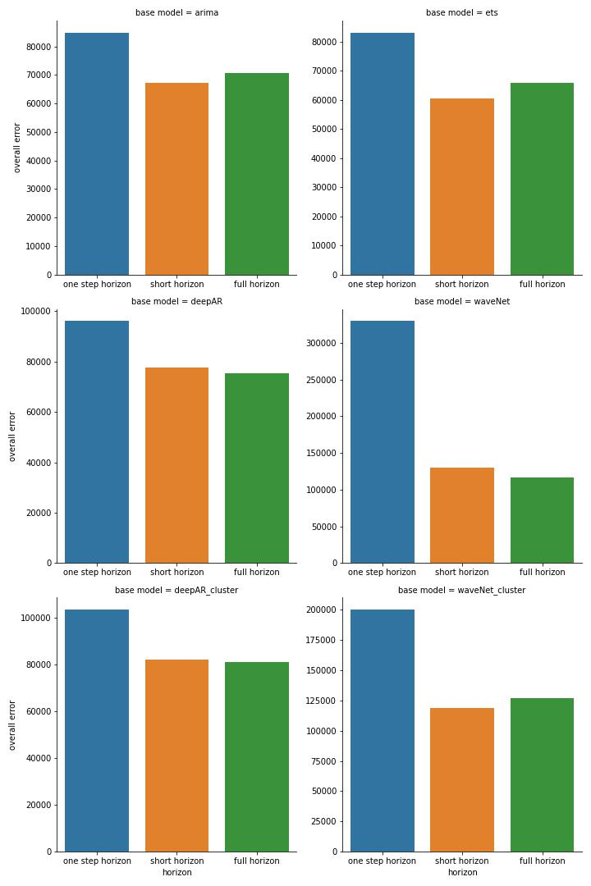

**Labour**

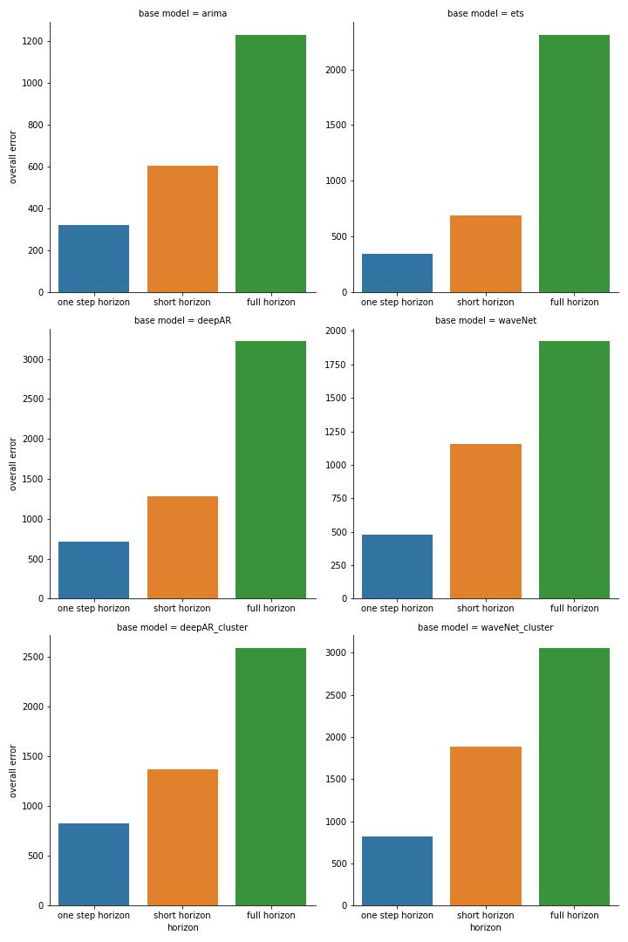

**Wikipedia**

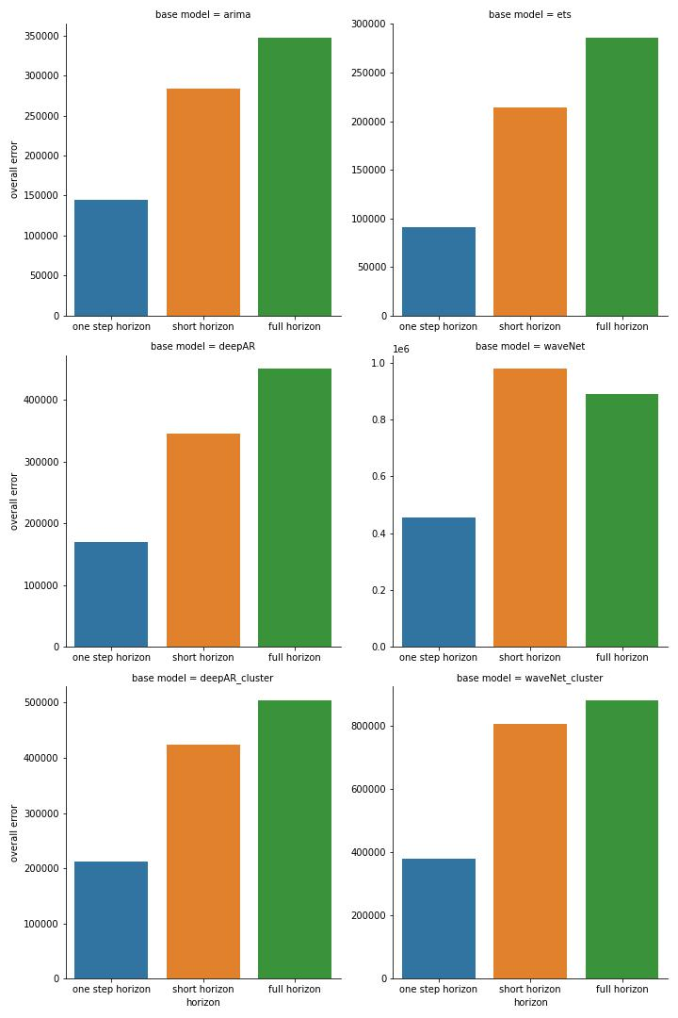

**Clustering Impact – Deep AR (It seems for deepAR the clustering has increased the overall error for all datasets except for Labour)**

Prison

Tourism

Labour

Wikipedia

**Clustering Impact – WaveNet (**Opposite observation for WaveNet – clustering has some improvement but not for Labour dataset**)**

Prison

Tourism

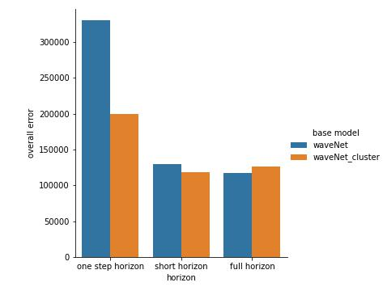

Labour

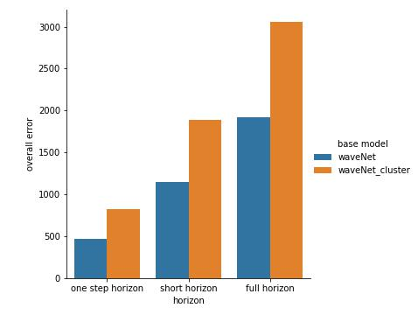

Wikipedia

